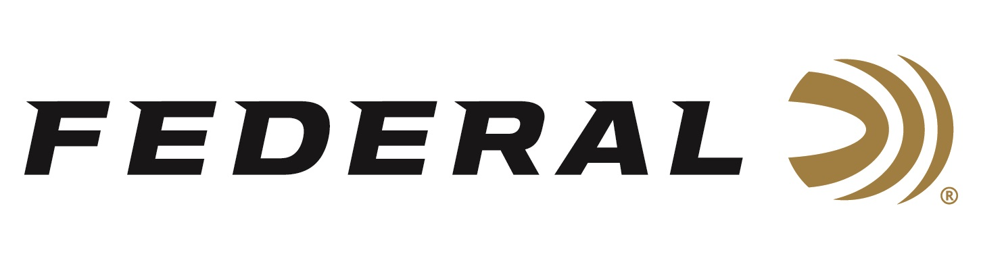

FOR IMMEDIATE RELEASE

Conservation Organizations Adapting on “It’s Federal Season” Podcast

ANOKA, Minnesota – December 17, 2020 – COVID-19 has been tough on conservation organizations and their fundraising models. Organizations like Pheasants Forever have canceled their highly successful banquet programs and recently announced the cancelation of the annual Pheasant Fest slated to be held in Sioux Falls, SD in February of 2021. The silver lining, the uncertainties are also energizing and reactivating enthusiasts to dust off their shotguns and get outside to properly social distance while chasing upland birds on the prairies and grasslands. Joining the “It’s Federal Season” podcast to discuss all things upland hunting is Bob St. Pierre, Chief Marketing and Communications Officer for Pheasants Forever and Quail Forever.

Episode No. 16 - Onward and Upland
https://www.federalpremium.com/this-is-federal/podcast/

“Pheasants Forever and Quail Forever are some of Federal’s oldest partners in conservation,” said Jason Nash, Federal Ammunition’s Vice President of Marketing. “They, like many other organizations, are having to adapt in these difficult times and we applaud the innovative ways they are still having conversations with their members and hunting enthusiasts and still doing the important grassroots work to preserve habitat and increase hunting opportunities,” said Nash. In this extended discussion, St. Pierre talks about the positive increase in license sales, the ammunition he loads in his shotgun, the successes of a great social media campaign, what to look for in order to have late season success, plus a little talk about his new puppy. This is a conversation you won’t want to miss.

In the Tech Talk segment, Product Director Rick Stoeckel weighs in on the features and benefits of Federal Ammunition’s Prairie Storm, including enhancements to the product and new offerings into popular sub-gauges like 16 and 28 gauge. Before closing the podcast, find out what promotions are currently running and take advantage of some great offers from Federal Ammunition.

Federal Ammunition can be found at dealers nationwide or purchased online direct from Federal. For more information on all products from Federal or to shop online, visit www.federalpremium.com.

Press Release Contact: JJ Reich
Senior Manager – Press Relations
E-mail: VistaPressroom@VistaOutdoor.com
About Federal Ammunition
Federal, headquartered in Anoka, MN, is a brand of Vista Outdoor Inc., an outdoor sports and recreation company. From humble beginnings nestled among the lakes and woods of Minnesota, Federal Ammunition has evolved into one of the world's largest producers of sporting ammunition. Beginning in 1922, founding president, Charles L. Horn, paved the way for our success. Today, Federal carries on Horn's vision for quality products and service with the next generation of outdoorsmen and women. We maintain our position as experts in the science of ammunition production. Every day we manufacture products to enhance our customers' shooting experience while partnering with the conservation organizations that protect and support our outdoor heritage. We offer thousands of options in our Federal Premium and Federal® lines-it's what makes us the most complete ammunition company in the business and provides our customers with a choice no matter their pursuit.

